1. 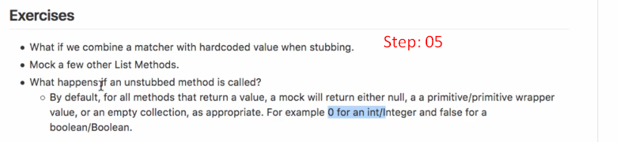 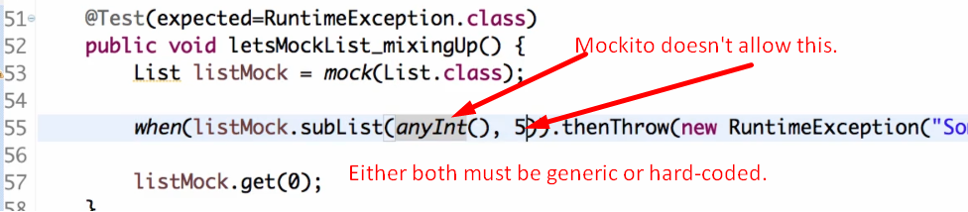
2. 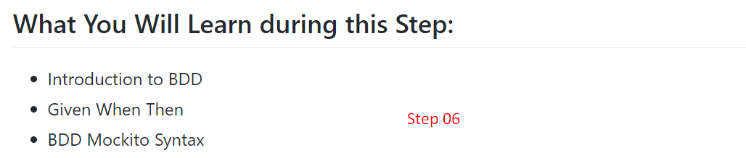
3. **What is BDD** (Behaviour-Driven Development)?
4. Let’s try to understand with an example.
5. You know that most of the Agile projects use user-story.
6. You’re given a user-story.
7. If we’re properly doing behaviour development, we will create scenarios around this user story.
8. 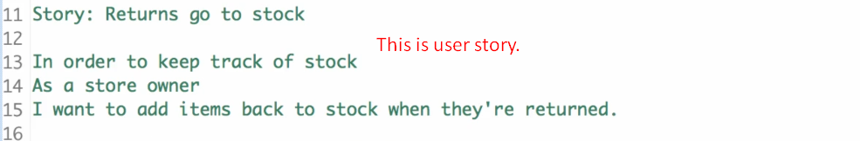
9. **NOTE**: We write a scenario in “**Given-When-Then**” format.  
   Actually, we split a user story into multiple scenarios (“**Given-When-Then**”)
10. Then we start writing tests (in the same format “**Given-When-Then**”) for each of these scenarios.  
    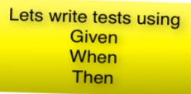
11. 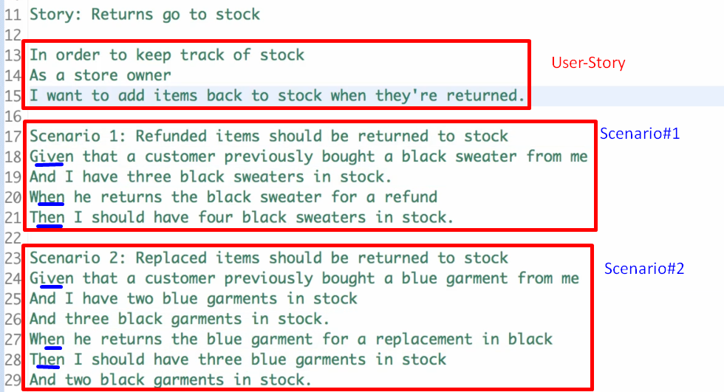
12. “**Given-When-Then**”:
    1. **Given**:
       1. It is setup for the scenario.
       2. **Example**: I’ve 3 black sweaters in stock.
    2. **When**:
       1. It is the actual method call means the System Under Test (SUT). The method which we want to test.
       2. **Example**: When a customer returns a black sweater for a refund.
    3. **Then**:
       1. It is a set of asserts that something has happened.
       2. **Example**: Now the stock must have 4 black sweaters.
13. “Given-When-Then” is a good way to write tests for a class.  
    Now what Mockito did is it came up with a specific class which is called BDD Mockito which contains specific methods to write test in “Given-When-Then” format.
14. Let’s use the BDD methods from Mockito.
15. 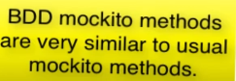
16. **NOTE**: Even syntax of mockito (Not talking about BDD Mockito), allows us to write “Given-When-Then” format.
17. Following Code snippet is BDD Style without using BDDMockito.  
    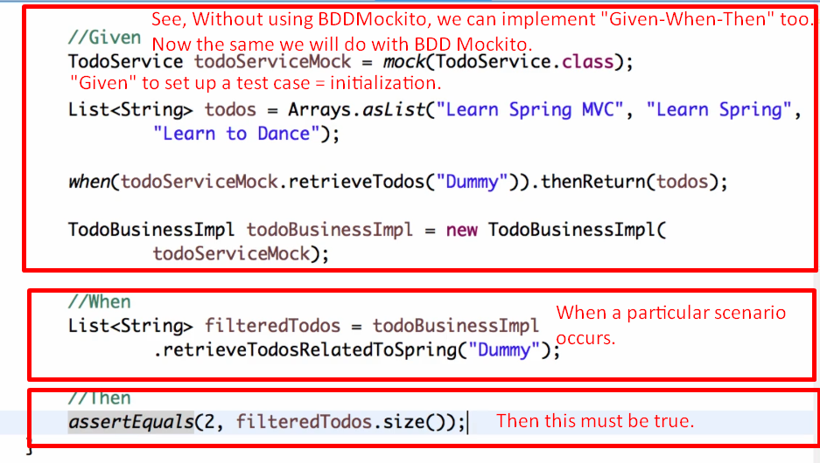
18. 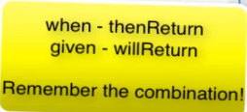
19. 